General Procedure

Responsable(s):

- Ângela Afonso – Sala P0-C-077; Ext. 47047/92903;
email:angelaafonso@medicina.ulisboa.pt
- Joaquim Polido Pereira – Sala P0-C-077; Ext. 47047;
email: joaquimpereira@medicina.ulisboa.pt
- Sérgio Dias- Sala P0-C-077; Ext. 47047;
email: sergiodias@medicina.ulisboa.pt

AUTHOR: Ângela Afonso APPROVAL:

CONTENTS

Pag.
1. SCOPE 3
2. DEFINITIONS 3
3. DESCRIPTION / PROCEDURE 3
A. Biobanco-IMM requirements 3
B. Circuits for sample entry 5
C. Circuits for samples exit 6
D. Pricing Policy 7
E. Period of storage samples 8
4. RECORDS 8
5. INFORMATION 8
A. Responsable(s): 8
B. Documentation: 8

1. SCOPE
This standard operating procedure defines the operation rules of the Biobanco-IMM.

2. DEFINITIONS
IMM: Instituto de Medicina Molecular
BBMRI: BioBanking and Biomolecular Resources Research Infrastructure
LIMS: Laboratory Information Management System

3. DESCRIPTION / PROCEDURE
The mission of Instituto de Medicina Molecular (IMM), Faculdade de Medicina da Universidade de Lisboa is to foster biomedical, clinical and translational research in Portugal and support the post-graduate scientific formation of young graduates, physicians and other health professionals.
We consider that innovation in biomedical research will allow not only to improve the knowledge of the disease mechanisms but also to develop novel diagnostic and prognostic tests and new treatments.
The Biobanco-IMM is built on the spirit of IMM mission being a support structure for research activities. The Biobanco-IMM will have a significant impact in the scientific activity of Centro Académico de Medicina de Lisboa (CAML), which will be reflected in an increased number of patents and partnerships aiming at the development of novel medical concepts. Our vision is that Biobanco-IMM will contribute to public health promotion and society welfare, but will also have the potential to act as a catalyst for novel national and international cooperation between researchers, research institutions and pharmaceutical industry.
The Biobanco-IMM is approved by the Institutional Ethics Committee and by the National Commission for Data Protection and it is a partner of the European network of Biobanks (BBMRI).
The specific objectives of Biobanco-IMM are:

- Collect a wide variety of human biological samples associated with relevant clinical information.
- Ensure the quality of the stored material through standardized quality tests developed according to the international recommendations.
- Administer the sample usage based on scientific and ethic criteria evaluated by the Scientific Commission of Biobanco-IMM.
- Join the national network of tumor banks and the European network of biobanks (BBMRI).

A. Biobanco-IMM minimum requirements
Infrastructures
- Office space with capacity for 2 collaborators, informatics hardware and archive;
- Sample collection room, reception and direct access to the exterior;
- Sample processing laboratory;
- Cell culture room;
- Storage room with ultrafreezers and liquid nitrogen containers.

Equipment

- Cold equipment - -80ºC ultrafreezers and -196ºC liquid nitrogen containers with temperature control system. The -80ºC ultrafreezers have a probe system to ensure that any fault is detected on time. The temperature of this room is controlled and kept stable allowing the best working conditions for the cold equipment.
- Security system – The building where Bibanco-IMM is based has 24h security control and the Biobanco-IMM rooms have also restricted access. A mobile phone from the technical supervisor of the Biobanco-IMM is available to any emergency.
- Rapid freezing unit (recipient for liquid nitrogen transport).
- Storage organization – drawers, racks, boxes, paraffin samples archive, slides archive.
- Informatics hardware – Labels printer, 2D barcode reader and computer.
- Software – The dedicated software used in Biobanco-IMM is LIMS from Labware. This system allows to perform the management of the samples from the entry until the exit, as well as to store all the information associated with each sample. Different users have different levels of access to the database according to the sample usage.
Team
The biobank of the IMM has the following organization:

- Joaquim Polido Pereira, MD – Co-director
Supervises operations and coordinates the activities of the scientific and technical committes. Clinical support and medical communication
- Sérgio Dias, PhD- Co-Director-
Supervises operations and coordinates the activities of the scientific and technical committes.
- Joana Caetano-Lopes, PhD - project manager
Keeps track of the Biobanco-IMM projects and advises on collection and quality of samples.
- Ângela Afonso, MSc – technical supervisor
Preparation, storage, quality control of the samples and management of the database.
- Ricardo Pires, BSc – tumor area consultant
Tumor area adviser and the liaison between the Biobanco-IMM and the national network of tumor banks.
- Rita Cascao, PhD-Responsible for the cell culture
Responsible for cell culture in Biobanco-IMM. Processes and stores samples of cell culture.
- Ana Sofia Zhao, MSc-Tech Lab
Responsible for collecting, processing, storage, collection and quality control samples. Data entry in the database
- Telmo Catarino, MSc-Tech Lab
Responsible for collecting, processing, storage, collection and quality control samples. Data entry in the database

Scientific committee – with the mission of defining sample use policy
Alexandre Mendonça, Dulce Brito, Gabriel Miltényi, Joana Caetano-Lopes, Joaquim Ferreira, Luis Costa, Ruth Geraldes, Sandra Casimiro, Sofia Oliveira..

Technical commission–with the mission of ensure the legal and technical framework for proper functioning.
Alexandra Maralhas, Teresa Conceição, Andreia Machado, Filipa Nunes, Margarida Gago, José Braga.

The Biobanco-IMM is authorized by the ethics committee of the North Lisbon Hospital Center - Hospital de Santa Maria (adopted September 17, 2008) to collect and store samples for scientific research. The clinical data associated with the samples collected is authorized by the National Data Protection Commission (authorization number 7435/2011 of 11 July 2011).

B. Circuits for sample entry
Research project based circuit: The sampling is performed under the responsibility of the researcher in the context of a research project. A collection protocol should be agreed with the Biobanco-IMM. The investigator collects according to the specified technical conditions and forwards the samples to the Biobanco-IMM or notifies it to collect them through a previously agreed circuit .

The Biobank Circuit: Sampling performed by the Biobanco-IMM

The Biobanco-IMM makes agreements with specific services from the hospital for systematic collection of some types of biological samples. A protocol is established in which the whole or part of the sample (according to whether or not the sample will be needed also for diagnosis purposes) is intended for the Biobanco-IMM.

Sampling protocol
a. Check the relevant data to be collected with the samples (date, time of collection, sample type, Hospital department, responsible for collection, the donor's personal information, such as age and sex).
b. Check for the existence of personal data and relevant clinical information of the donor.
c. Check for informed consent.
d. Before sample processing, check for important notes such as "Special Handling Instructions."
e. In the case of tissue samples, check if there is a histopathological diagnosis and evaluation by a pathologist.
This protocol is detailed in Standard Operating Procedures SOP.BIO.002, SOP.BIO.003, SOP.BIO.004, SOP.BIO.005 and SOP.BIO.006.

Processing of the samples after entry biobank

a. Immediately after entering the Biobanco-IMM, a code is assigned to each sample.
b. The samples will be processed in accordance with internal rules of good practice created by the Biobanco-IMM.
c. Classification of the quality of the sample / clinical data / storage (through the software LIMS).
d. The data and clinical information accompanying the sample are inserted into the database of the Biobanco-IMM, as well as a copy of the informed consent of the donor.
This process is detailed in Standard Operating Procedures SOP.BIO.002, SOP.BIO.003, SOP.BIO.004, SOP.BIO.005 and SOP.006.

Schematically

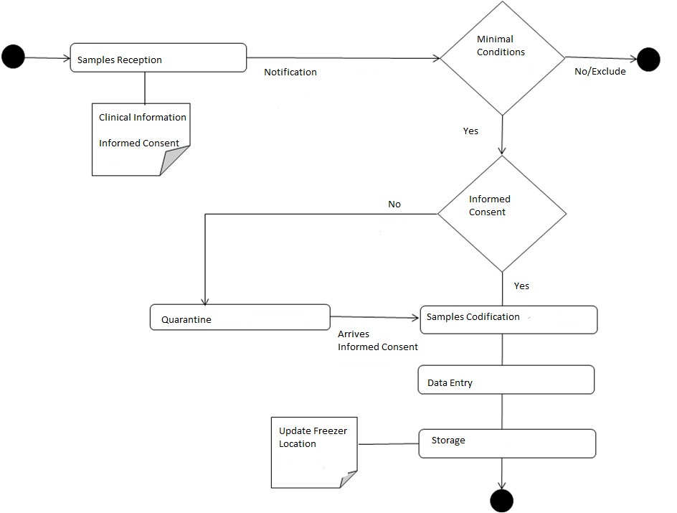

C. Circuits for samples exit

Circuit 1: Samples collected directly by the Biobanco-IMM are available to be shared. The Scientific Commission validates the request of the samples after the evaluation of a project submitted by the requesting researchers. The project should be previously approved by the local Ethics Committee. The meeting of the Scientific Committee for validation of the request should take place within one month after the application.

Circuit 2: Samples collected in the context of research projects can be shared with or without restrictions after validation by the Scientific Committee and with prior approval of the project by an Ethics Committee. The restrictions should be established by written agreement when these samples integrate the Biobanco-IMM. The samples remain in the Biobanco-IMM, regardless of the researcher move to other working place. When a sample is requested, the Biobanco-IMM will promote the direct contact between the requesting researcher and the PI of the collection. Regardless of the level of restriction the PI of the collection will be always contacted aiming at establishing a collaborative agreement, if this will be in the interest of the collection’s PI.
The transfer of samples involves sharing a minimal amount of clinical data, which will be defined by the group responsible for depositing the sample. There may be clinical information associated with the sample only usable after specific permission of the PI of the collection.
The possible categories of restricted access to a biological sample are:
Green: The sample can be shared without restriction.
Yellow: The donor group provides a portion of the sample (50%) for sharing without restrictions.
Orange: The donor group provides a portion of the sample to be shared (30%) but has the right to veto requests from other researchers, if properly justified in the meeting of the Scientific Committee.
Red: The donor group does not provide sample for sharing for a predefined period of time (up to 5 years). After this period, the researcher and the biobank should re-assess the level of restriction.

Schematically

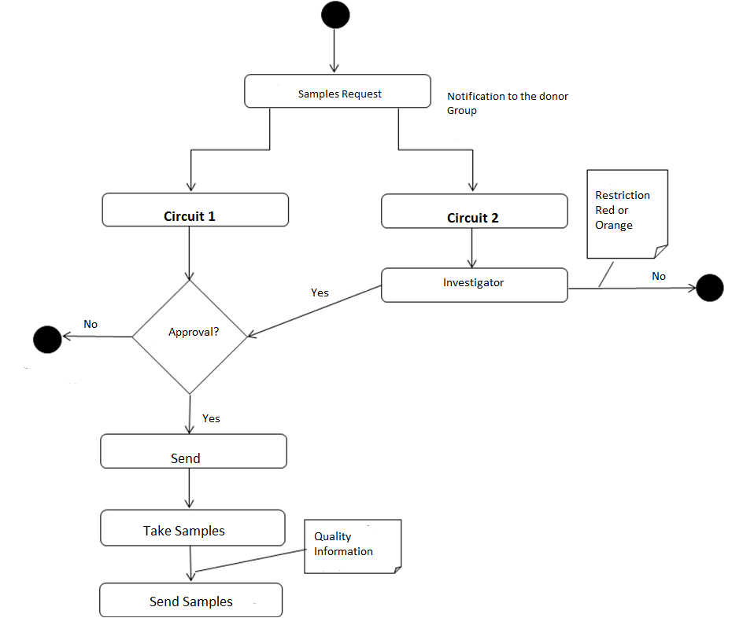

D. Pricing Policy
The pricing policy to be practiced by the Biobanco-IMM should take into consideration the following aspects:

- The entry of samples from IMM groups has no associated payment.
- In the case of samples from external groups the conditions should be individually evaluated, depending on the volume and type of samples.
- Payment is only applied to the sampling and is calculated according to the cost of processing. There are no anticipated costs related to equipment maintenance or fees related of the professionals involved.

E. Period of storage samples
After 10 years of storage the research group responsible for the samples and the scientific committee will discuss the conditions of restricted access and relevance of maintaining the samples in the Biobanco-IMM. Exceptions are the samples in red category whose revision is performed after five years of storage.

4. RECORDS

Records’ Identification | Indexation | Archive Responsible
Form 001 | Intranet | Ângela Afonso
Autorização Prévia da Comissão Nacional de Proteção de Dados nº 7435 | Sala P0-C-077 | Ângela Afonso
Autorização Prévia da Comissão de ética do Hospital Santa Maria | Sala P0-C-077 | Ângela Afonso
Art. 19 da lei 12/2005 | Sala P0-C-077 | Ângela Afonso

5. INFORMATION

A. Responsable(s):
- Ângela Afonso – Sala P0-C-077; Ext. 47047/92903;
email:angelaafonso@medicina.ulisboa.pt
- Joaquim Polido Pereira – Sala P0-C-077; Ext. 47047;
email: joaquimpereira@medicina.ulisboa.pt
- Sérgio Dias- Sala P0-C-077; Ext. 47047;
email: sergiodias@medicina.ulisboa.pt

B. Documentation:
- Art. 19 da lei 12/2005
- Lei 67/ 98

