SpectroFlo (CYTEK Aurora)

AUTHORS: Andreia Santos APPROVAL: Mariana Fernandes
Margarida Araújo
Mariana Fernandes
Rute Gonçalves

Índice
Daily Quality Control 3
Cleaning 3
Running a Daily QC 3
Experiments 5
Opening an Experiment 5
Creating a Default Experiment 5
Creating a New Experiment + Acquisition + Unmixing + Cleaning (Tubes) 6
Creating a New Experiment + Acquisition + Unmixing + Cleaning (Automated Sample Loader) 14
Autofluorescence Management 25
Instrument Shutdown 28
Importing and Exporting your data 28

Daily Quality Control
(1st user of day on weekdays before 9h, weekends and holidays)

Cleaning
Start up the fluidics:
- Perform 1 cycle of Clean Flow Cell, only with water.
- Run 3 mL of Water+Azide for 30 minutes. This will ensure the cytometer is clean, the fluidics are stabilized, and the lasers are fully warmed up.
- In the Acquisition workspace, select a default experiment by double-clicking on it, change FCS gain to 40 and Threshold to 300.000. Load a tube with 3 mL of Water+Azide.
Note: Every time a tube is removed, the system automatically back-flushes. For this reason, it is necessary to wait until the backflush is finished before loading a new tube.
- Click RUN and change the speed to HIGH on the software.
Events should be below 7 evt/s (ensure water is clean).

Running a Daily QC
- Load a tube of SpectroFlo beads (1 drop of beads in 300 μL of sheath or PBS) onto the SIP.
- Click QC & Setup from the Get Started menu.
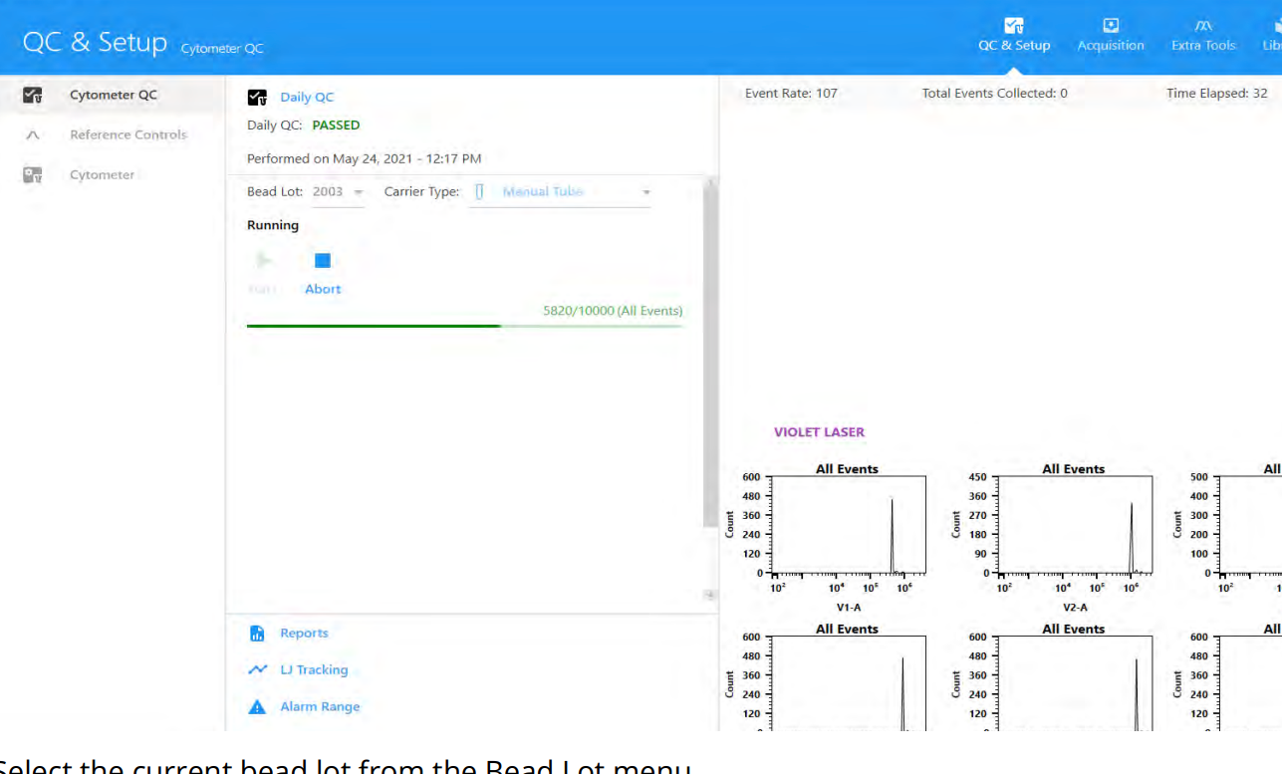
- Select the current bead lot number from the Bead Lot menu.
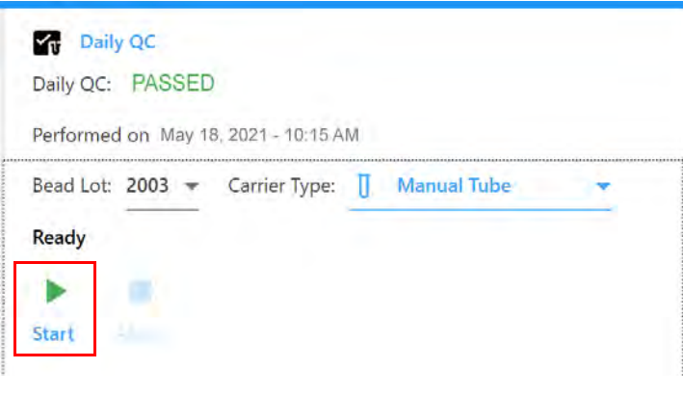
- Ensure the correct Carrier Type is selected.
- Click Start.
The procedure will take approximately 3 to 5 minutes to complete.
Note: if there is more than one peak on the histograms of the detectors, make new beads and restart the QC.

- When Daily QC successfully completes, click View Report to see the Daily QC report.
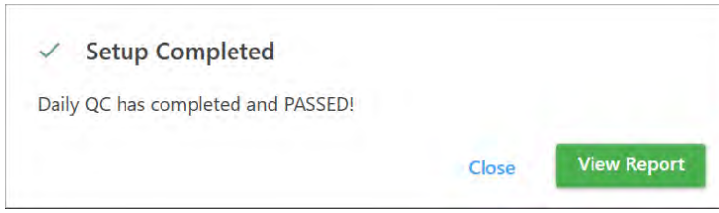
- Open the report and look at gain change, %rCV and LASER delays. Compare the values with previous reports.
- If QC fails, reach the UCF emergency contact and follow the guidelines on the “SOP.UCF.046 – CYTEK Aurora Troubleshooting” and in the Daily QC Failed dialog.
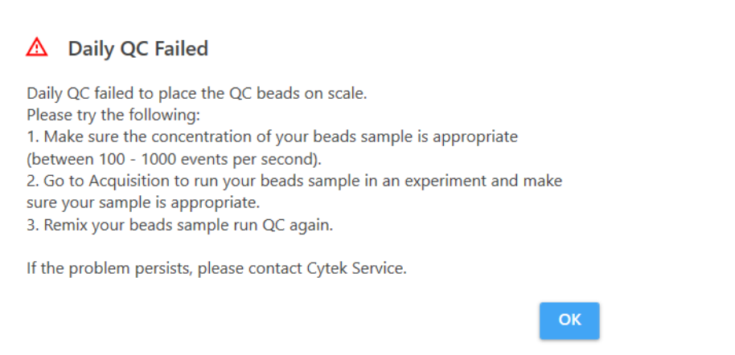
- After QC is over, clean the beads out of the system by running 5 minutes of FACSClean solution, followed by 5 minutes DI water.
- Aurora is ready to be used.

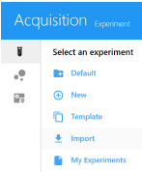
Experiments

Opening an Experiment
Click Acquisition from the Get Started menu.
Experiments can be created using several different methods. The following table describes the options in the Acquisition Experiment menu:

Method | Description
Default | Opens a new experiment with one group containing one tube and a set of labels and fluorescent tags in a default experiment worksheet template. The default experiment is user configurable. It is the quickest way to begin sample acquisition.
New | Opens the New Experiment Wizard to guide you through creating an experiment.
Template | Allows you to select from a list of saved experiment templates
Import | Imports an experiment ZIP file that was exported.
My Experiments | Allows you to select from a list of saved experiments.  Use it to open experiments you already ran, as you may want to review the data or acquire more samples.  Use it also to export your experiments (see section “Importing and Exporting your data”)  Original experiments can also be duplicated without data, which is equivalent to opening an experiment template. Right-click an experiment and select Duplicate (with or without data). You can also choose Duplicate with Reference group data.

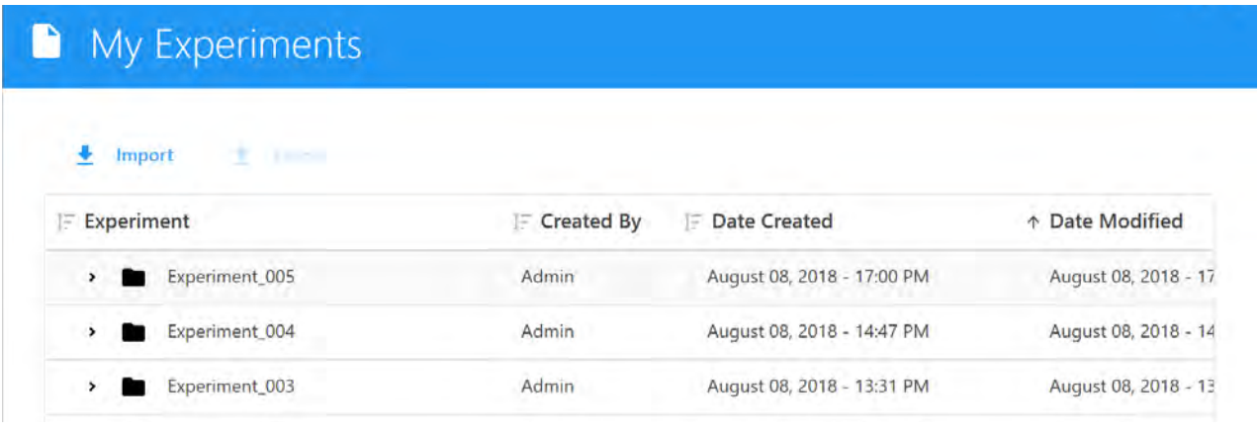

Creating a Default Experiment
Use the default experiment option to quickly begin an experiment. The default experiment contains a set of fluorescent tags, however all parameters are user configurable.
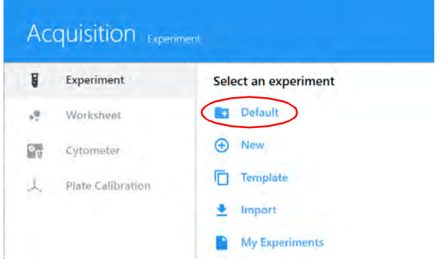
- Click Default in the Acquisition Experiment menu.

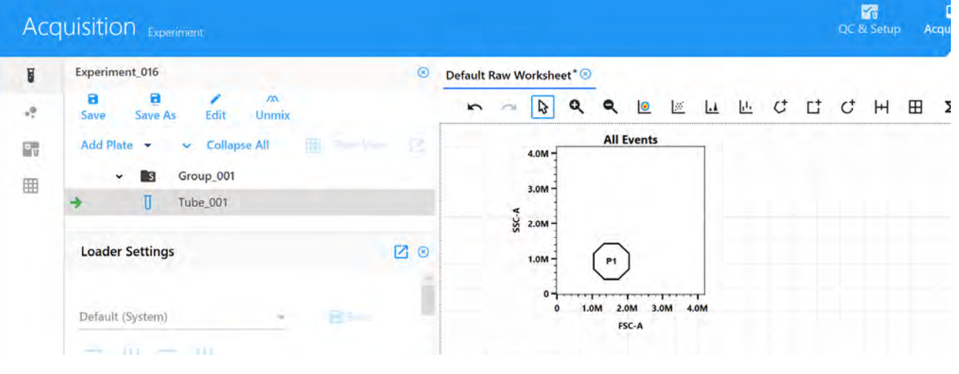
The default experiment opens with a default raw worksheet.

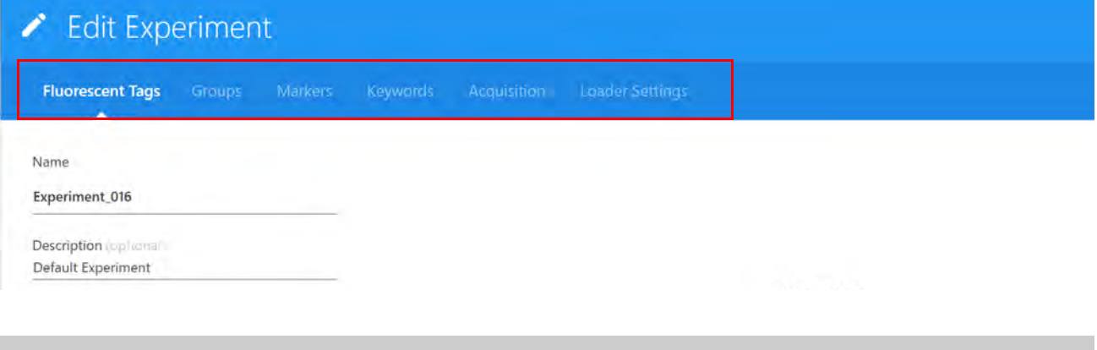
- Click Edit. The same wizard appears as when creating a new experiment. Follow the steps to select the fluorescent tags, add groups, and define markers, keywords, acquisition settings/worksheets, and Loader settings.

Creating a New Experiment + Acquisition + Unmixing + Cleaning (Tubes)
If working with 96-well plates or 40-tube racks, please see the next section “Creating a New Experiment & Acquisition (Automated Sample Loader)”.
- (Optional) If using tubes other than the polystyrene 5 mL FACS tubes provided by the facility perform a SIT calibration:
  - Install the tube you are using in the cytometer.
  - In SpectroFlo, go to Cytometer (left menu bar) > Calibrate SIT
  - A dialog appears prompting you to enter the SIT Lift Distance (distance in millimeters from the tip of the SIT to bottom of the well). Enter the lift distance, then click Calibrate SIT.
  - Check the depth of the sample line in the well. If it’s satisfactory, click OK. If it needs to be raised or lowered, adjust the SIT Lift Distance and click Calibrate SIT.
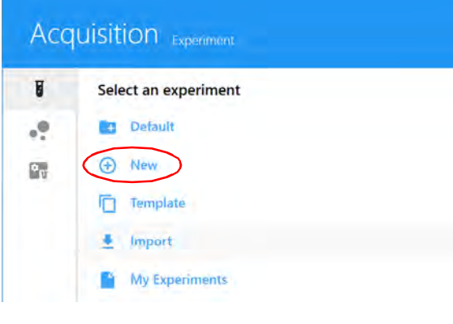
- Click New in the Acquisition Experiments menu.
- Enter an experiment name.
- Select all the fluorescent tags used in the experiment by:
- Double-clicking in the fluorochromes at the library list;
- Clicking in the plus sign “Add”.
- Dragging and dropping the fluorochromes from the library list to the selection area;
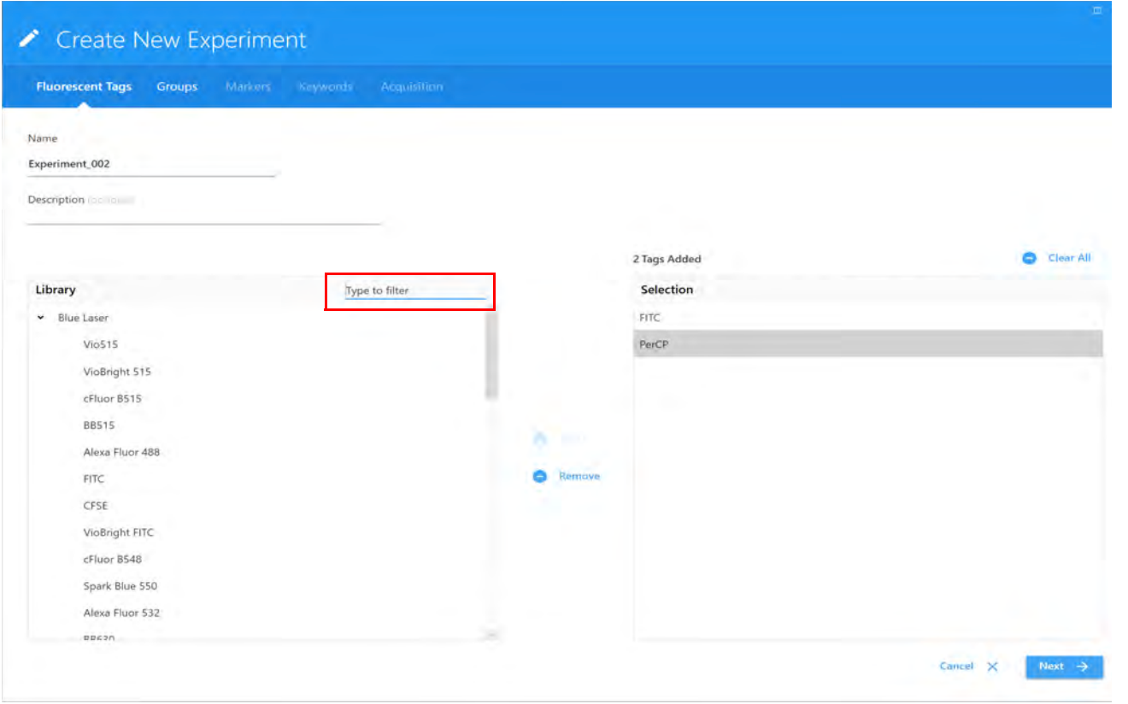
- Typing the fluorochromes name at “type to filter” field.
Tags are organized in default groups by laser. To remove fluorochromes from the experiment list, click in the minus signal “remove”, or double-click in the fluorochrome name in the selection panel.
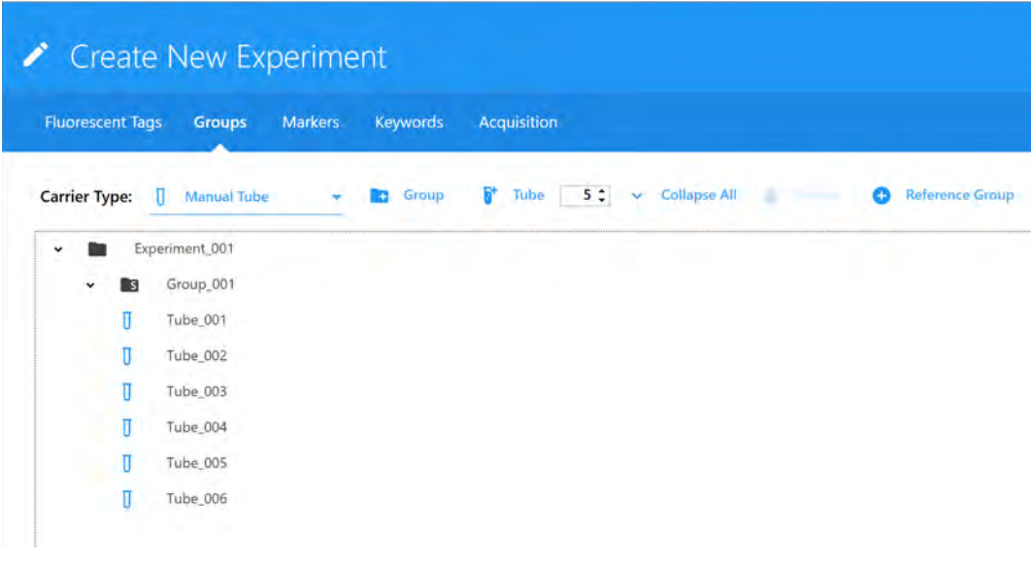
- Once all fluorescent tags have been chosen from the Library list, confirm the list in the selection pane, then click Next to create groups.
- Ensure the correct Carrier Type (Manual Tube) is selected.
- To create a reference group:
- Select (+) Reference Group to create a group for tubes that will be used as reference controls.
- Then Choose:
- The control type (Cells or Beads) for the unstained control. The unstained control needs to be of the same type and prepared in the same way as the samples.
IMPORTANT: Define an unstained control for autofluorescence by selecting its control type (beads or cells). The unstained control needs to be of the same type and prepared in the same way as the samples, as this will ensure accurate unmixing and autofluorescence quantitation.
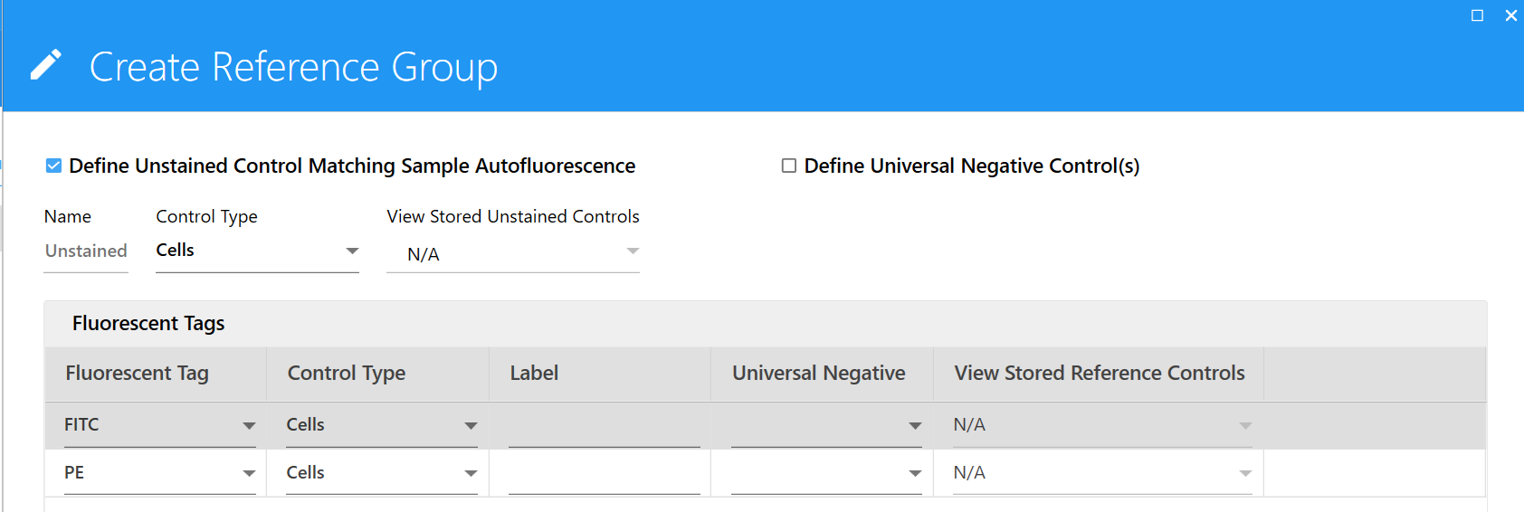

- The control type (Cells or Beads) for each single-stained control (fluorescent tag).
- The negative control for fluorescent tags (the respective unstained control).
- The label of each fluorescent tag (write the marker/antigen name).
- If applicable, select Define Additional Negative Control(s) for Spillover Calculation to use a different unstained control to calculate spillover for your reference controls. Then enter a name and control type for this extra negative control. For example, if test samples are cells and the reference controls are beads, all with only positive peaks, you will need to run a separate tube of negative beads for the spillover calculation. An extra negative control is not needed if your unstained autofluorescence control (and sample) is the same type as the reference controls.
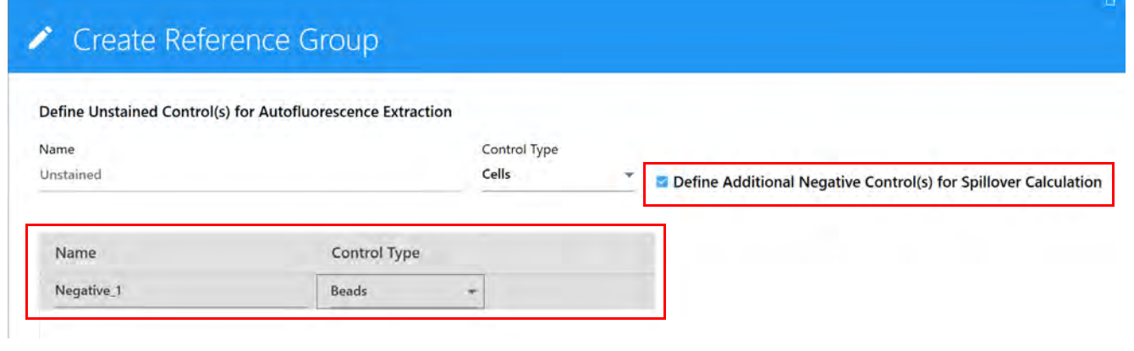
- Click Save.
Once the reference group has been created, entries for each of the references will be displayed. Each of the reference group tubes/wells will have an icon with the letter R associated with it under the reference group.
- Create groups for your samples and add tubes by selecting (+) Group and/or Tube.
To add a new group, click on the group “+” icon (folder icon) and name it.
  - To add tubes, click on the tube “+” icon until you have the desired number of tubes, or write the number of tubes needed and then click the tube icon.
  - To remove tubes, or groups, click in the remove trash bin icon.
- On the Markers menu, add labels for the sample tubes. They can be chosen from the Labels list on the right, typed directly into the table, or copied and pasted. Labels can be added at the group or tube level and can be applied to multiple cells selected at once. Labels are required for reference controls if you selected Label/Lot Specific Unmixing in the Acquisition Preferences.
- Click Next when all the tubes are labeled.
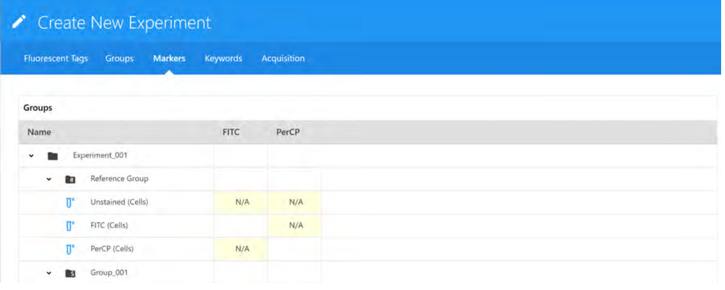
When all groups are created, click next and write down the names for all the molecules assigned to each fluorochrome in the groups created (except the reference group) by typing the name in the assigned place, or by dragging and dropping the name of the markers from the labels list.

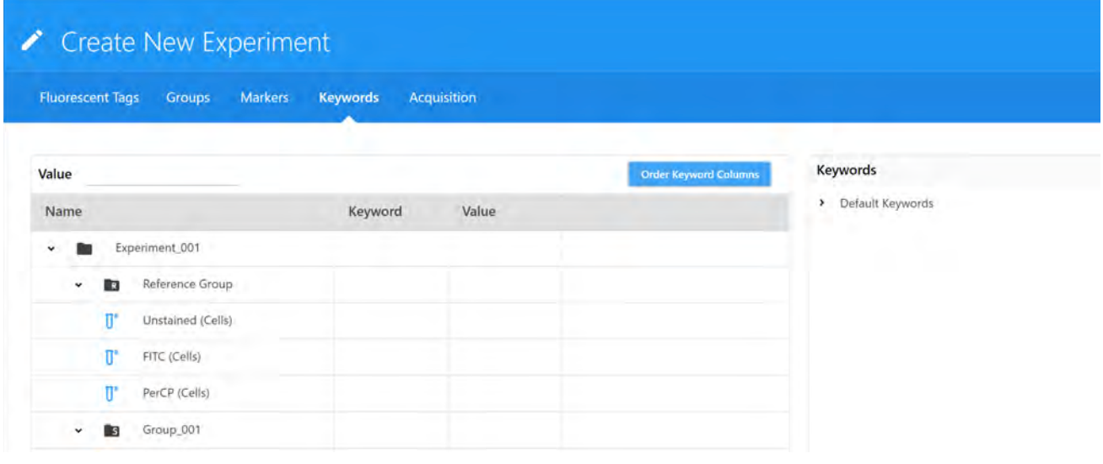
- (Optional) Add keywords to sample tubes. Enter custom keywords and click Next. Custom keywords can be added at the experiment, group, or tube level. You must define the custom keywords in the Library before you can add them to an experiment. Drag and drop the keywords from the Keywords list on the right to the experiment, group, or tube and enter keywords values as needed. You can also copy and paste custom keywords across different tubes in this wizard.
- On the Acquisition menu, select the worksheets for acquisition. Worksheets can apply to all tubes in the experiment, group, or individual tubes.
- Select the Default Raw Worksheet (Raw) for the reference controls.
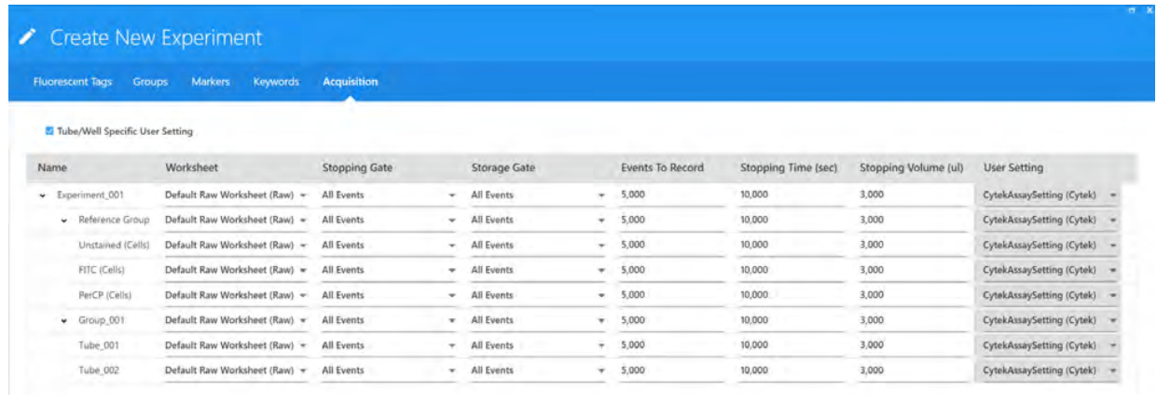
- Select the desired (or Default) Unmixed Worksheet for the samples.
- Select the stopping gate, events to record, and stopping time(sec) or stopping volume (ul).
For the Unstained Control, record the same amount of events as you do for your samples (or at least 100.000)
For the Single Colors:
If acquiring beads, we recommend collecting 5,000 singlet events.
If acquiring cells, we recommend collecting 30,000 events of the desired population.
Note: The number of events to acquire depends on the target population. For example, you may need to acquire 10,000 to 20,000 events to get 2,000 of the desired population. Approximately 1,000 to 2,000 events is needed in both the negative and positive populations of each control for accurate unmixing.

Once the worksheet and stopping criteria have been defined, click Save and Open to open the new experiment. To make any changes to the experiment, click Edit above the group/tube hierarchy.
If you click Save As Template, the setup will not be applied to your sample, since it will be saved in the library.

- Acquire and record the reference group tubes.
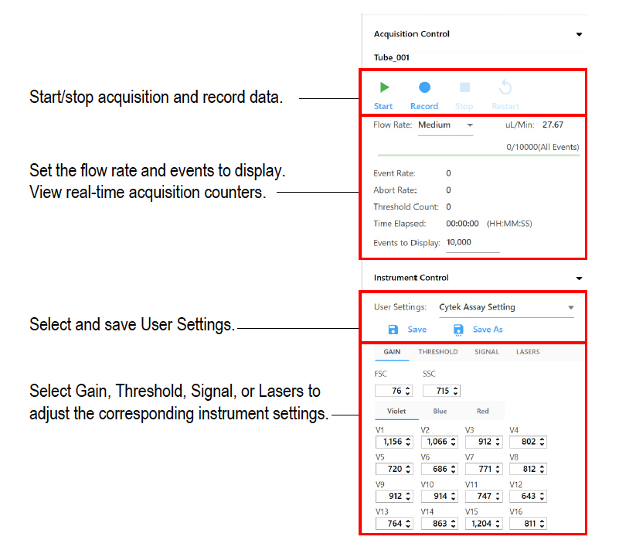
  - Ensure CytekAssaySetting is selected.
  - Load the first reference control (unstained).
  - In the Acquisition Control, set the flow rate to Low and then click Start.
  - In Instrument Control, adjust FSC and SSC gains and threshold to your population of interest.
  - Adjust P1 gate to catch the population of interest.
  - View all the controls, as well as one multi-color sample, and make any instrument adjustments to ensure populations are on scale before you begin recording.
  - Record the unstained control tube.
  - Load and record the other reference controls.
- When all reference controls are recorded, click Unmix in the upper-left toolbar:
  - For the unstained controls, we recommend selecting "Use Control from Experiment”, if unmixing with controls you acquired in the experiment.
  - If necessary, for the stained controls, select the “From Library” checkbox, if unmixing with reference controls run in QC & Setup.
  - Click Next.
  - Use the Identify Positive/Negative Populations window to include the positive and negative populations for each fluorescent tag in the appropriate gate. Note that only the data plots for the samples you acquired are displayed, not for reference controls that you chose to use from the library. You may find it more efficient to view the data in columns—adjust the gates in the FSC vs SSC plots first, then adjust the histogram gates, finally adjust the gates on the spectrum plots.
- Move the polygon gate in the FSC vs SSC plot on the left to include the singlet population. Hold down Ctrl to move all the polygon gates at once.
- Move the positive interval gate in the histogram to include the positively stained population. Move the negative interval gate to include the negative population.
- Move the interval gate on the spectrum plot on the right to select the channel that exhibits the brightest fluorescence intensity. This channel is the peak emission channel for the fluorescent tag.
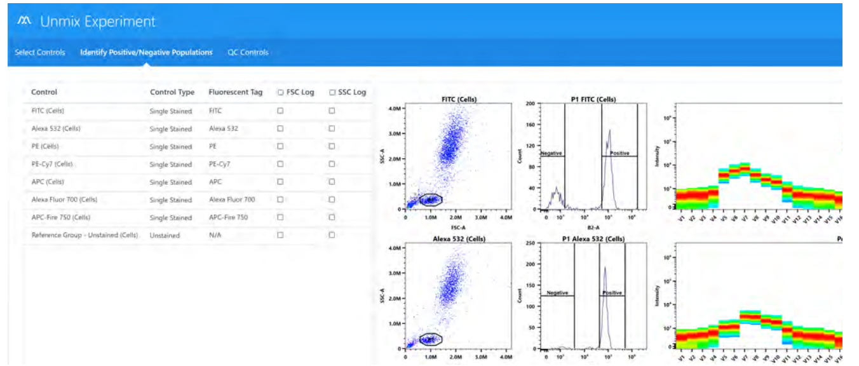
- If one of the controls is questionable or does not contain sufficient data, you can reacquire it or append to it, then unmix again.

Two options allow you to view how the two reference controls compare – spectral profile and Similarity™ Index.
- Spectral Profile displays the emission spectrum of the unmixing controls against benchmark spectra designated by the user. The benchmark reference control spectra appear in red and the reference controls appear in black.
A Similarity Index appears to the right of the plots. A value closer to 1 indicates similar spectral signatures, while a value closer to 0 indicates spectral signatures that are not similar. For comparison to benchmarks, the value should be close to 1. If the value is below 0.97, it will be flagged with a yellow warning symbol. This indicates a mismatch of the unmixing control spectra with the benchmark spectra. If the Similarity Index falls below this value, it is imperative to check the unmixing control against the reference spectra provided in the fluorochrome guideline found in the Help menu. See “Similarity Matrix” in the following section.
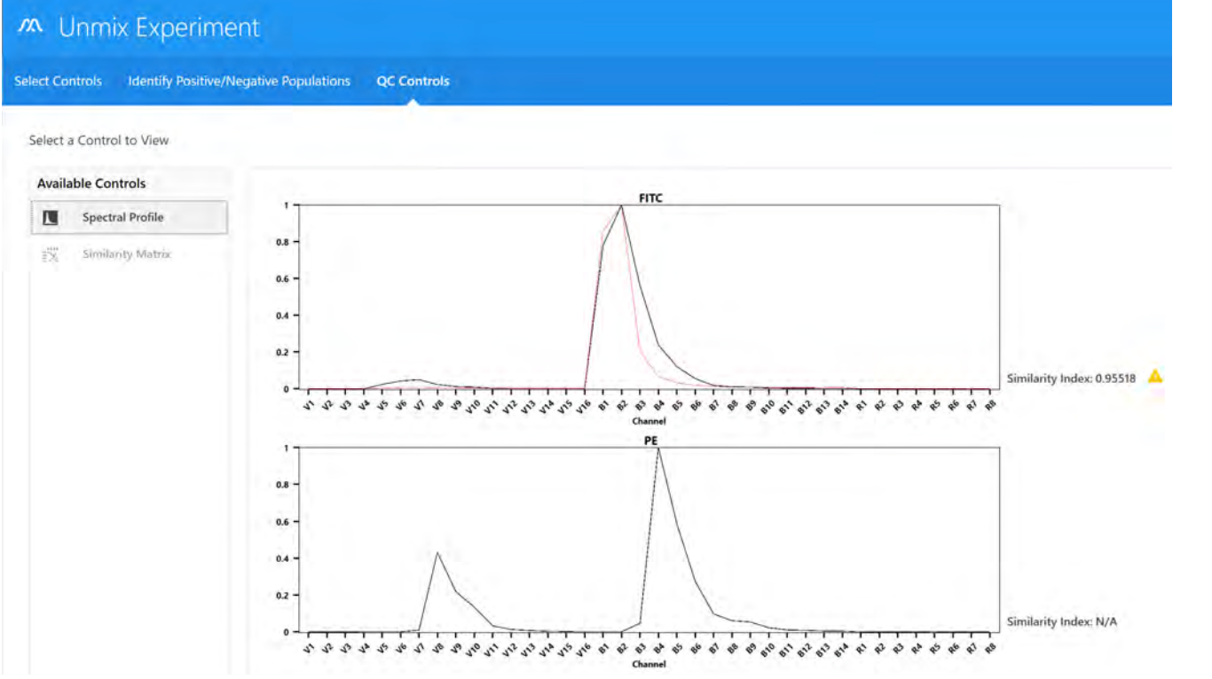
The Similarity Index can also be used when viewing and comparing the full spectral signatures of any two dyes. Dyes with similar spectral signatures can be challenging to resolve. In this case, it is best to use dyes with a Similarity Index ≤0.98. See spectrum.cytekbio.com for a full spectrum viewer tool.
If no benchmark control is established for a particular dye, that plot will only display a black line that represents the spectrum of the unmixing control. The Similarity Index will display N/A.

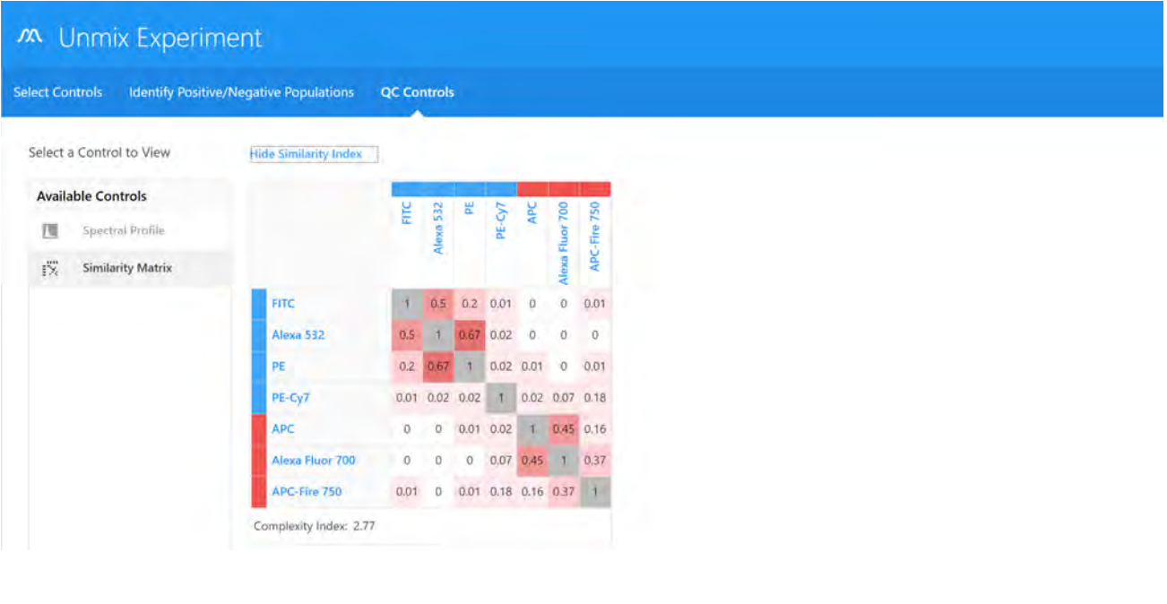
- Similarity Matrix displays a Similarity Index matrix and a Complexity™ Index value. Click View Similarity Index above the matrix to display the indices for each dye. The Similarity Matrix will display the Similarity Index for each dye against itself and all the other dyes to be unmixed in the experiment. The Complexity Index is a measure of how distinguishable a collection of spectral signatures are from each other when unmixed together. It calculates this by looking at the ratio of the Similarity Index of the worst overlapping combination of signatures to the best overlapping combination of signatures.

- Click Live Unmixing.
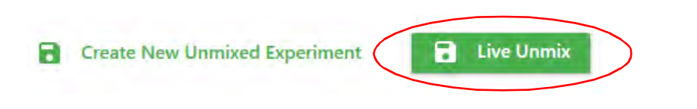

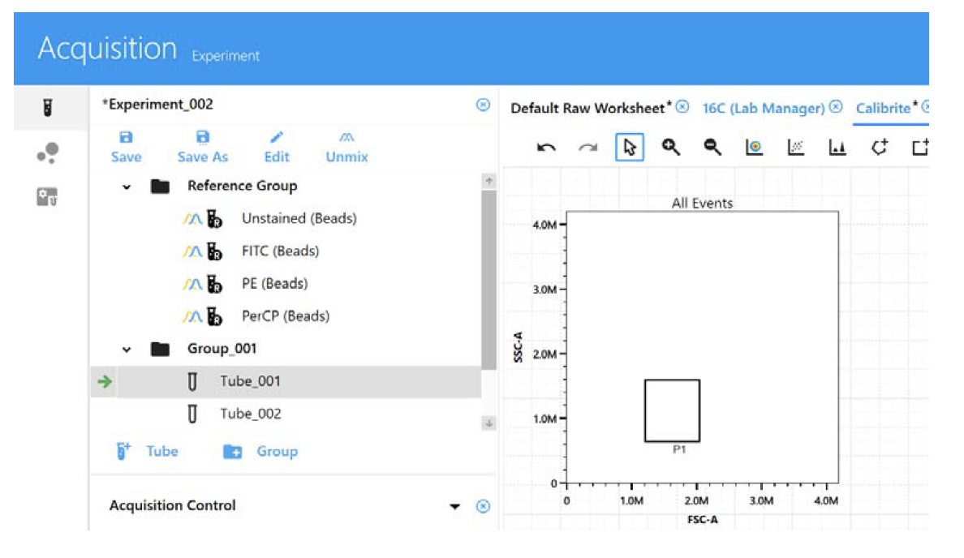
- The wizard closes and the experiment reappears. The reference group now has the unmixed icon to the left of the tube(s). Select an unmixed worksheet to view the unmixed data.
- Load the sample tube you wish to acquire. The green arrow indicates the tube is selected.
- Click Start, then Record.
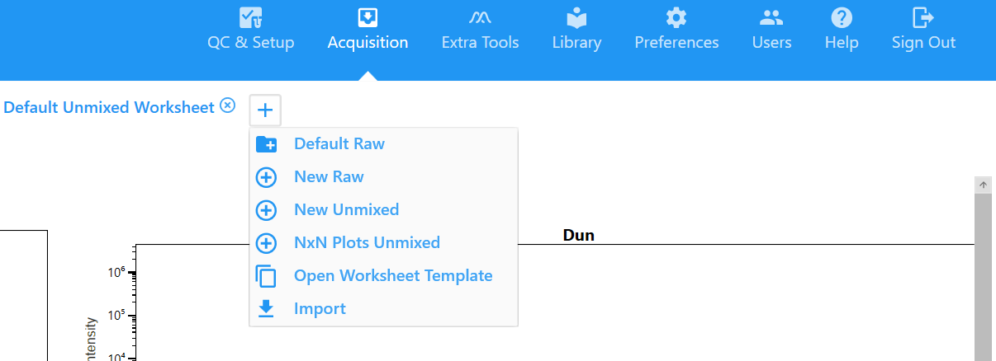
- Check on a NxN worksheet if the unmixing was well performed. Right-click on tube, select Properties and, if needed, on the Spillover menu, apply fine adjustments to the unmixed matrix.
- Record all tubes from your experiment.
- At the end of acquisition, perform the cleaning procedure:
- Perform a CLEAN FLOW CELL (FACSClean + Water with azide)
- Run 2 min FACSClean in HIGH.
- Run 2 min Water with azide in HIGH.
- If you are the last user of the day after 17h, perform a Fluidics Shutdown.

Creating a New Experiment + Acquisition + Unmixing + Cleaning (Automated Sample Loader)
- If working with tubes, please see the previous section “Creating a New Experiment & Acquisition (Tubes)”.
- Log in into your account in SpectroFlo.
- If there is a tube on the SIP, remove it.
96-well plates | 40-tube racks
Turn on the power switch of the Loader by pressing the black switch above the exit of the waste line (in the software, the loader icon must turn green). | Turn on the power switch of the Loader by pressing the black switch above the exit of the waste line (in the software, the loader icon must turn green).
Pull the lever towards you to bring the mixer forward
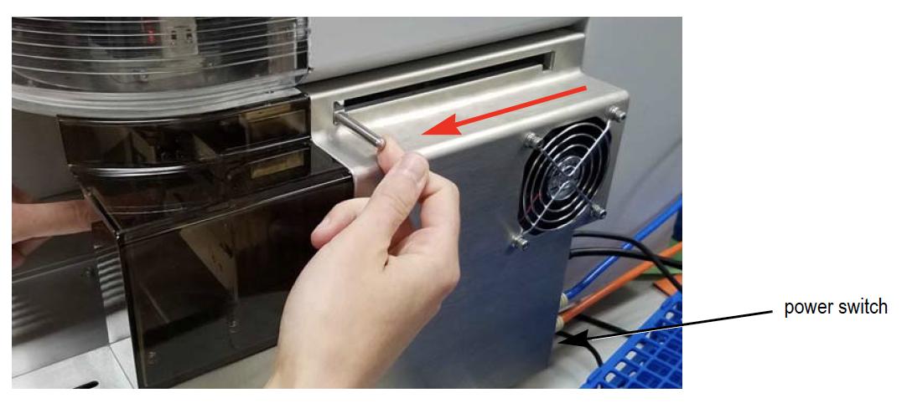
- Follow these steps:
- Perform a calibration of the SIT by following these steps (for 96-well plate or 40-tube rack):
Before running your experiment with a 40-tube rack, and if using tubes other than the polystyrene 5 mL FACS tubes provided by the facility, perform a SIT calibration:
  - If necessary, press “Eject” from either the QC & Setup or Acquisition module to eject the stage, bringing it forward.
  - Load a rack on the plate stage so that position A1 is located in the front-left corner.
  - In SpectroFlo, go to Cytometer (left menu bar) > Calibrate SIT
  - A dialog appears prompting you to enter the SIT Lift Distance (distance in millimeters from the tip of the SIT to bottom of the well).
  - Make sure there is a tube in the A1 position. Enter the lift distance, then click Calibrate SIT.
  - Check the depth of the sample line in the tube. If it’s satisfactory, click OK. If it needs to be raised or lowered, adjust the SIT Lift Distance and click Calibrate SIT.
Before running your experiment with a 96-well plate, you must perform a SIT calibration to set the proper SIT depth within the well:
  - If necessary, press “Eject” from either the QC & Setup or Acquisition module to eject the stage, bringing it forward.
  - Load an empty 96-well plate on the plate stage so that position A1 is located in the front-left corner.
  - In the Cytometer tab, from either the QC & Setup or Acquisition module, select Calibrate SIT.
  - A dialog appears prompting you to enter the SIT Lift Distance (distance in millimeters from the tip of the SIT to bottom of the well). Enter the lift distance, then click Calibrate SIT.
  - Check the depth of the sample line in the well. If it’s satisfactory, click OK. If it needs to be raised or lowered, adjust the SIT Lift Distance and click Calibrate SIT.
- Under Acquisition module (top right bar), create a new experiment.
  - Click New on the left panel (under the tube icon – “Experiment”).
- Under fluorescent tags, name the experiment and select all the fluorochromes used in the sample by:
  - Double-clicking in the fluorochromes at the library list;
  - Clicking in the plus sign “Add”.
  - Dragging and dropping the fluorochromes from the library list to the selection area;
  - Typing the fluorochromes name at “type to filter” field.
To remove fluorochromes from the experiment list, click in the minus signal “remove”, or double-click in the fluorochrome name in the selection panel.
- Click Next to create groups.
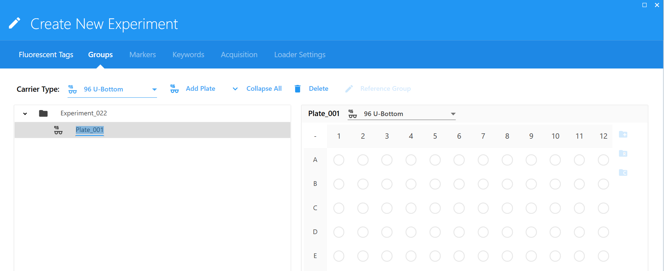
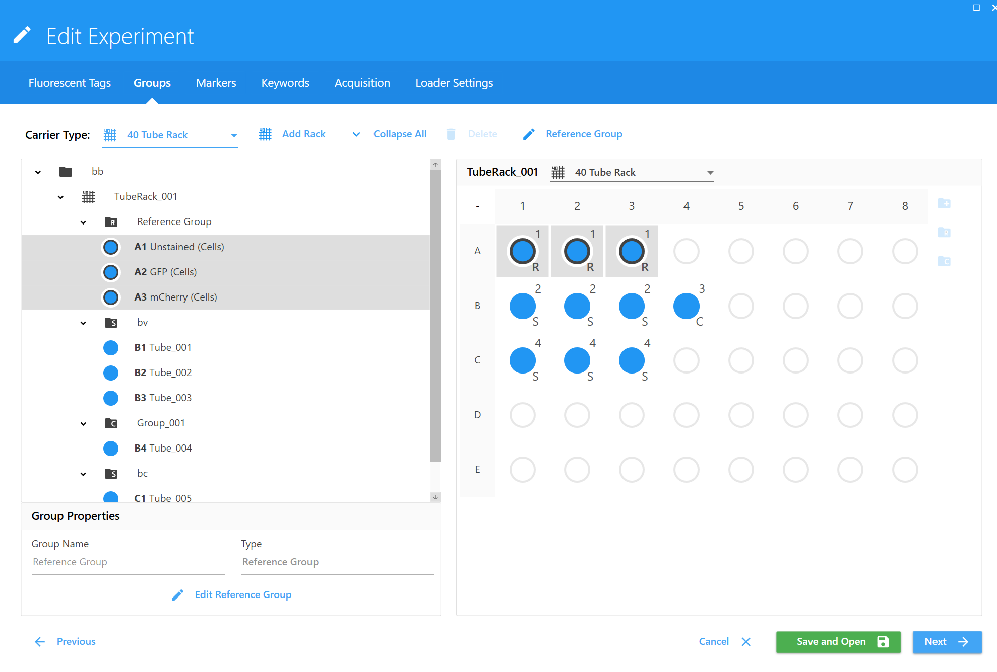
- Ensure the correct carrier type (96 U-, V-, Flat-Bottom or 40-tube rack) and click Add Plate/Rack. A plate/rack image appears on the right. Three icons at the far right allow you to add groups.
96-well plate
40-tube rack

- To create a reference group:
  - Click on the 1st well and select the reference group “R” icon. You will be prompted to define the reference controls.
  - Then choose:
    - The control type (beads or cells) for both unstained and fluorescent tags (single color controls).
IMPORTANT: Define an unstained control for autofluorescence by selecting its control type (beads or cells). The unstained control needs to be of the same type and prepared in the same way as the samples, as this will ensure accurate unmixing and autofluorescence quantitation
    - The negative control for fluorescent tags (the respective unstained control).
    - The label of each fluorescent tag (write the marker/antigen name).
  - If applicable, select Define Universal Negative Control(s) for Spillover Calculation to use a different unstained control to calculate spillover for your reference controls. Then enter a name and control type for this extra negative control. For example, if test samples are primary cells and some reference controls are cells from culture, only with positive staining, you will need to run a separate tube of negative cells from culture for the spillover calculation.
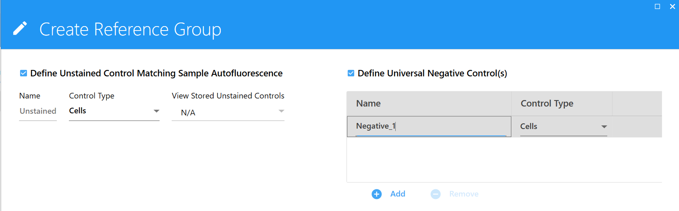
An extra negative control is not needed if your unstained autofluorescence control (and sample) is the same type as the reference controls.
  - Click Save to create the specified reference group.
If you want to go back, click on the Reference group list, and select “Edit Reference Group”.
- To add a group for samples:
  - On the plate image, click and drag to select a desired number of wells/tubes and choose the “+” icon.
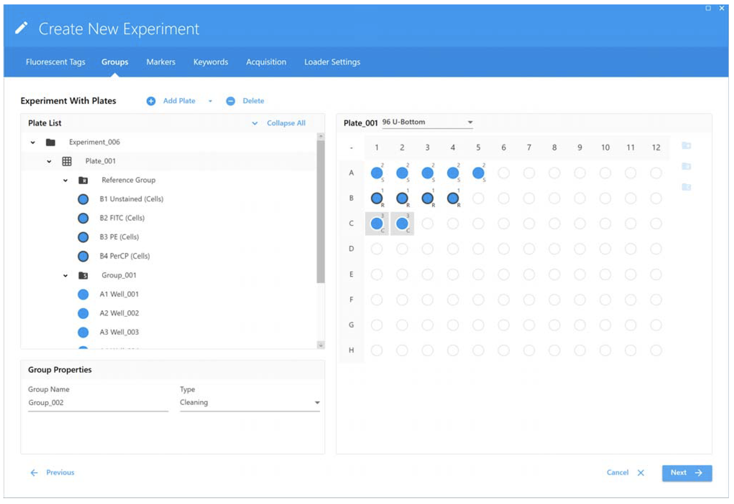
  - To remove tubes or groups, select them and click in the trash bin icon.
- In order to minimize carryover, especially if running sticky samples in a plate, we recommend adding cleaning wells between samples to thoroughly clean the mixing probe. Those clean wells are not recorded. To add a group for cleaning well(s), click and drag to select a desired number of wells and choose the “C" icon. For example, you can add PBS to wells to rinse the SIT and clean the mixing probe to prevent carryover.
- In the end, wells will be marked as sample (S), reference control (R), or cleaning (C).
- When all groups are created click next and write down the names for all the molecules assigned to each fluorochrome in the groups created (except the reference group). You can do this by typing the name in the assigned place, or by dragging and dropping the name of the markers from the labels list.
- (Optional) Click Next to add Keywords.
- Click Next to set the acquisition stopping gate and the events to be recorded.
For the Unstained Control: record the same amount of events as you do for your samples (or at least 100.000).
For the Single Colors:
If acquiring beads, we recommend collecting 5,000 singlet events.
If acquiring cells, we recommend collecting 30,000 events of the desired population.
Note: The number of events to acquire depends on the target population. For example, you may need to acquire 10,000 to 20,000 events to get 2,000 of the desired population. Approximately 1,000 to 2,000 events is needed in both the negative and positive populations of each control for accurate unmixing.

  - When selecting worksheets and acquisition settings, select the top level (group or experiment) to apply the settings to all wells/tubes within the group or experiment.
  - Afterwards, these parameters can only be changed if you go to “Edit” by right clicking on the tube, or if you select “Edit” on the left side of the panel; you have to save the changes.

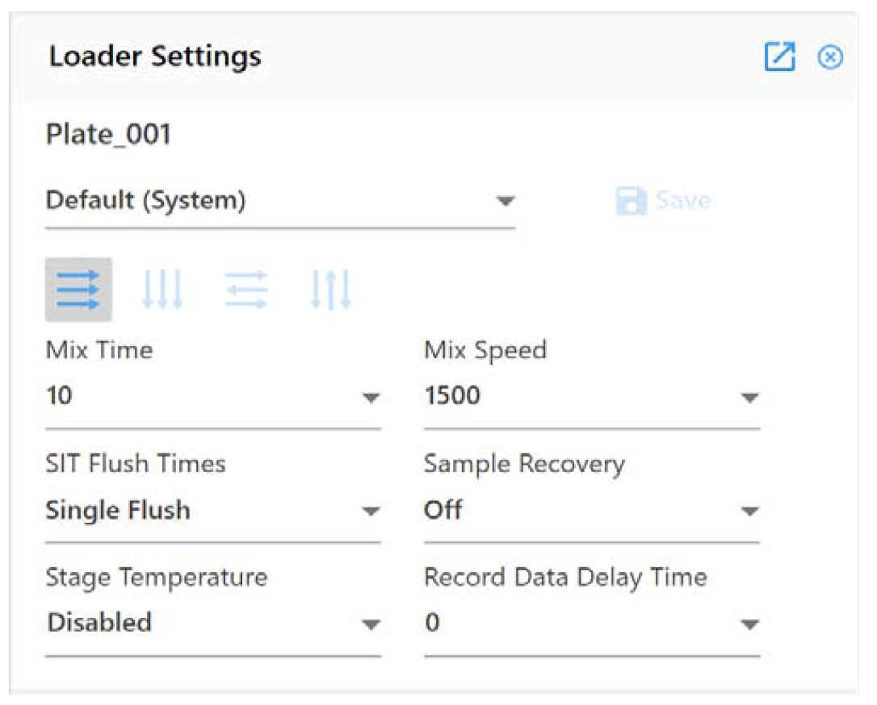
- Select the Loader Settings - these can be applied to all wells in the plate or at the group level:
  - Default
  - High Throughput
  - Low Carryover
  - Custom
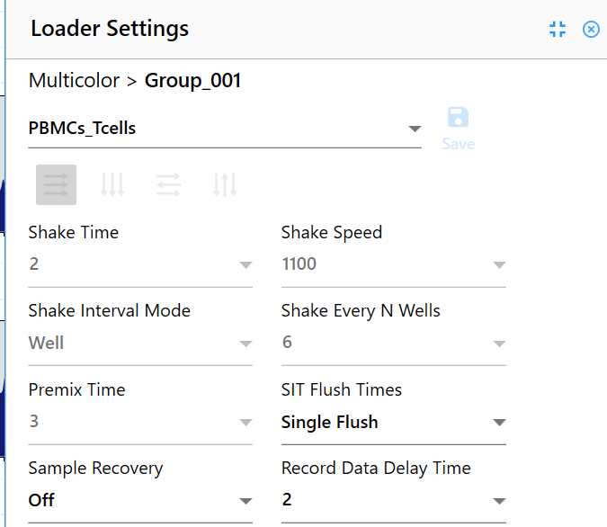
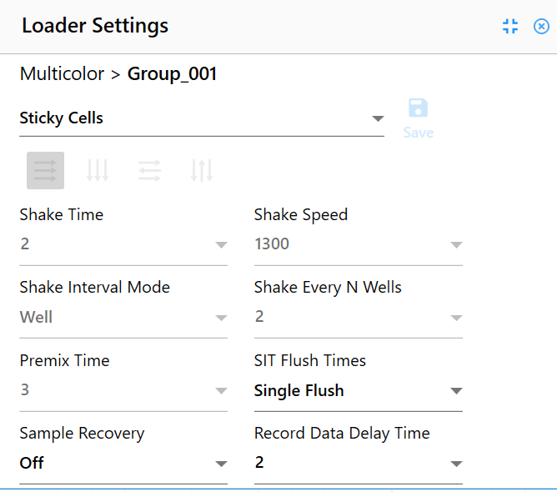
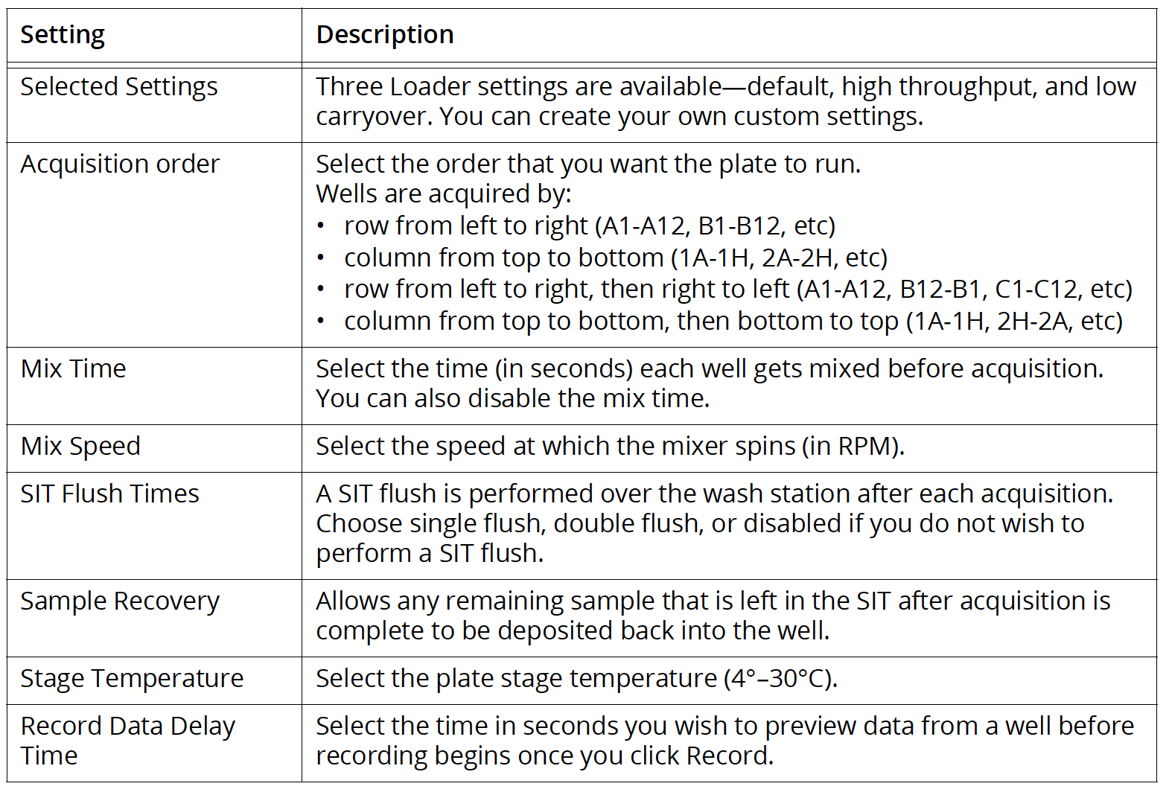
The Default settings work for most immunophenotyping applications. However, these can be adjusted depending on the cell types.
These are 2 examples (PBMCs and Sticky cells).

- After setting up the experiment, click Save and Open.
To make any changes to the experiment, click Edit above the group/well hierarchy or by right clicking on the well.
- Acquire and record the reference group wells:
  - Ensure CytekAssaySetting is selected.
  - Select the first reference control well/tube (unstained).
  - In the Acquisition Control menu, set the flow rate to Low and then click Start.
  - In Instrument Control, adjust FCS and SSC gains and threshold to your population of interest.
  - Adjust P1 gate to your population of interest.
  - View all the controls, as well as one multi-color sample, and make any instrument adjustments to ensure populations are on scale before you begin recording.
  - Record the unstained control well/tube.
  - Select and record the other reference controls.
- When all reference controls are acquired, click Unmix in the upper-left toolbar:
  - For the unstained controls, we recommend selecting "Use Control from Experiment”, if unmixing with controls you acquired in the experiment.
  - If necessary, for the stained controls, select the “From Library” checkbox, if unmixing with reference controls run in QC & Setup.
  - Click Next.
  - Use the Identify Positive/Negative Populations window to include the positive and negative populations for each fluorescent tag in the appropriate gate. Note that only the data plots for the samples you acquired are displayed, not for reference controls that you chose to use from the library. You may find it more efficient to view the data in columns—adjust the gates in the FSC vs SSC plots first, then adjust the histogram gates, finally adjust the gates on the spectrum plots.
    - Move the polygon gate in the FSC vs SSC plot on the left to include the singlet population. Hold down Ctrl to move all the polygon gates at once.
    - Move the positive interval gate in the histogram to include the positively stained population. Move the negative interval gate to include the negative population.
    - Move the interval gate on the spectrum plot on the right to select the channel that exhibits the brightest fluorescence intensity. This channel is the peak emission channel for the fluorescent tag.
    - If one of the controls is questionable or does not contain sufficient data, you can reacquire it or append to it, then unmix again.

Two options allow you to view how the two reference controls compare—spectral profile and Similarity™ Index.
- Spectral Profile displays the emission spectrum of the unmixing controls against benchmark spectra designated by the user. The benchmark reference control spectra appear in red and the reference controls appear in black.
A Similarity Index appears to the right of the plots. A value closer to 1 indicates similar spectral signatures, while a value closer to 0 indicates spectral signatures that are not similar. For comparison to benchmarks, the value should be close to 1. If the value is below 0.97, it will be flagged with a yellow warning symbol. This indicates a mismatch of the unmixing control spectra with the benchmark spectra. If the Similarity Index falls below this value, it is imperative to check the unmixing control against the reference spectra provided in the fluorochrome guideline found in the Help menu. See “Similarity Matrix” in the following section.
The Similarity Index can also be used when viewing and comparing the full spectral signatures of any two dyes. Dyes with similar spectral signatures can be challenging to resolve. In this case, it is best to use dyes with a Similarity Index ≤0.98. See spectrum.cytekbio.com for a full spectrum viewer tool.
If no benchmark control is established for a particular dye, that plot will only display a black line that represents the spectrum of the unmixing control. The Similarity Index will display N/A.

- Similarity Matrix displays a Similarity Index matrix and a Complexity™ Index value. Click View Similarity Index above the matrix to display the indices for each dye. The Similarity Matrix will display the Similarity Index for each dye against itself and all the other dyes to be unmixed in the experiment. The Complexity Index is a measure of how distinguishable a collection of spectral signatures are from each other when unmixed together. It calculates this by looking at the ratio of the Similarity Index of the worst overlapping combination of signatures to the best overlapping combination of signatures.

- Click Live Unmixing.

- The wizard closes and the experiment reappears. The reference group now has the unmixed icon to the left of the tube(s). Select an unmixed worksheet to view the unmixed data.
- Select the well/tube you wish to acquire. The green arrow indicates the tube is selected.
- Click Start, then Record Well.
- Check on a NxN worksheet if the unmixing was well performed. Right-click on tube, select Properties and, if needed, on the Spillover menu, apply fine adjustments to the unmixed matrix.
- Record all wells/tubes from your plate/rack.
- Revert the plate Loader setup steps to leave Aurora ready for acquisition in tubes:
96-well plates | 40-tube racks
Turn off the power switch of the Loader by pressing the black switch above the exit of the waste line (in the software, the loader icon must turn grey). | Turn off the power switch of the Loader by pressing the black switch above the exit of the waste line (in the software, the loader icon must turn grey).
Pull the lever towards the wall to bring the mixer back to the parking station
  - In the Cytometer Menu click “Load” to park the plate loader

- At the end of acquisition, perform the cleaning procedure using tubes:
  - Perform a CLEAN FLOW CELL (FACSClean + Water with azide)
  - Run 2 min FACSClean in HIGH.
  - Run 2 min Water with azide in HIGH.
  - If you are the last user of the day after 17h perform a Fluidics Shutdown.
Note 1 – Minimum Volume
When acquiring a sample, a boost is applied to quickly deliver it to the flow cell. This process results in the consumption of 35 μL of sample, a volume that is neither acquired nor recorded. We recommend a minimum volume of 80 μL of sample per well/tube, keeping in mind that approximately 35 μL will be lost.

Note 2 – Sample Recovery mode in the ASL system
If you are working with the ASL (96-well plate or Rack), you can recover 18 μL of the 35 μL stated in the previous note by turning ON “Sample Recovery” on the Loader settings. This feature instructs the system to put back the volume, that is still in the sample line, into the well/tube. Keep in mind that this process of sample recovery makes the acquisition process a bit slower.

Note 3 – Maximum Well Volume
When acquiring samples in a 96-well plate, use a maximum volume of 160 μL/well, to avoid cross contamination during the shaking/mixing process. If you need to have more volume in a well, you can go up to 200 μL, but make sure you set the shake speed to its lower value of 1100 rpm.

Autofluorescence Management
One of the advantages of full spectrum analysis is the ability of identifying and extracting the autofluorescence signature of cells out of your sample. In some cases, this feature will increase the resolution of the molecules stained with fluorescent antibodies. However, if the autofluorescence signal is around 10³ or less, extracting autofluorescence is not recommended, as it will introduce distortions in the visualization of the data and resolution will not improve.
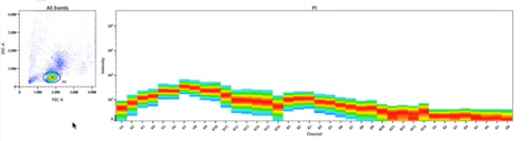
Profile of unstained cells, showing that autofluorescence of cells in this sample has significant intensity in some regions of the spectrum, especially when cells are excited by the violet laser.
- If you have only one autofluorescence signature in your unstained sample (example above) you can extract it by:
  - Clicking on the “Unmix” icon on top of the Experiment panel.
  - On the bottom right of the Unmix Experiment window, check the option “Spectral Unmixing with AF extraction” to instruct the software to extract the autofluorescence as a separate parameter.
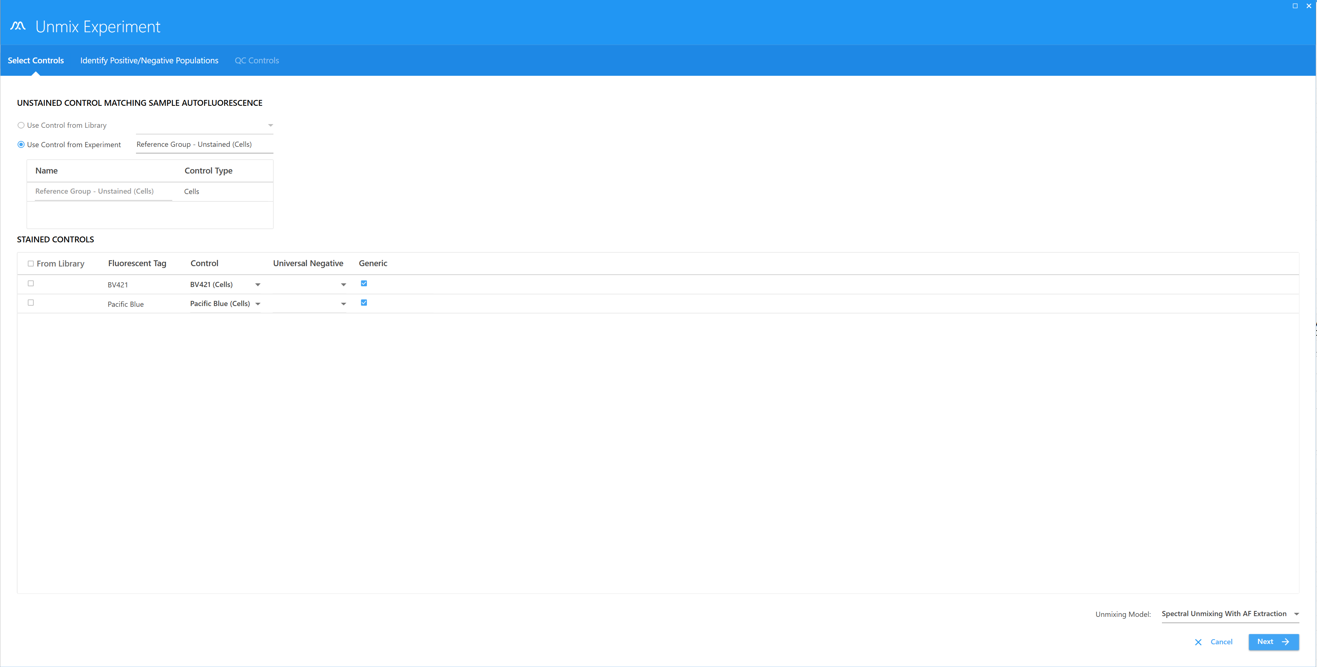
  - Click “Next” and adjust the gates if necessary.
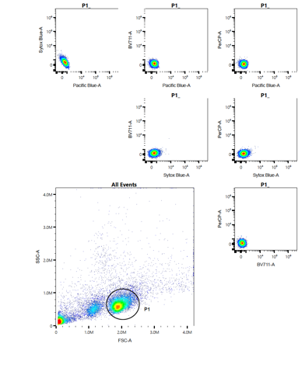
  - Click “Live Unmixing” and check on a NxN worksheet if the unstained sample displays a round population, negative for all fluorescence markers (see example below). If so, you can proceed with your analysis.

  - After autofluorescence extraction, it is often necessary to rescale the plots, as populations are often closer to the axes: select the plots to rescale > right click to select “Plot Properties” > under “Parameters” adjust the scales.
  - Autofluorescence can be visualized as a separate parameter in the dot plots: right-click on the dot plot axis and select AF (autofluorescence) to plot it against any other parameter.
  - If you go to an NxN worksheet and see that the unstained has signal in some/all fluorescence channels (see below), you need to further clean your unstained sample so that it is free of possible small autofluorescent populations or contaminants – We recommend you to consult the UCF staff to assist you on this procedure.
Note: NxN worksheets are Unmixed worksheets, meaning you can only access them after you have associated an Unmixing to your experiment.

- If, when you look at the spectral profile of your unstained (Raw Worksheet), you see overlaying fluorescences (a) you need to isolate these different fluorescent signatures (a_1 and a_2) and use them as extra Fluorescence Tags. Please contact the Flow Cytometry Unit staff if your unstained sample displays this type of profile.
a)
a_1)
a_2)

- In these cases, where you need to use autofluorescences as extra Tags, you have to provide the software with an unstained that will work as the negative for those autofluorescences. Your unstained should be PBS or Water or Media that displays no fluorescence.

After extracting the different autofluorescences and providing an unstained with negative fluorescence you can Unmix your data. You will now have the different autofluorescences as parameters in your dot plots.

Instrument Shutdown
After you end your experiment, please confirm in Agendo if anyone has made a reservation for Aurora after you. If you are the last user of the day after 18h on weekdays, or the last user on weekends and holidays, the system should be turned OFF. To shutdown Aurora, please follow these steps:
1) In SpectroFlo, either on the QC & Setup or Acquisition module menu, select Fluidics Shutdown.
2) Follow the prompts to load a tube with 3 mL of FACSClean, followed by a tube with 3 mL of Water with azide, followed by 3 mL of 30% Contrad, followed by 3 mL of Water with azide. The entire procedure takes about 6 minutes.
3) Leave the tube of Water with azide on the SIT. Make sure the SIT is submerged in the water.
4) Turn OFF the cytometer, exit the SpectroFlo software, and shutdown the workstation.

Importing and Exporting your data
After you finish recording your last sample, you can now export your data.

Important Notes
• The long-term storage of all data generated by the independent usage of Aurora is the responsibility of the researchers/groups who have collected the data.
• It is strongly recommended to export experiments from the SpectroFlo to the local folder immediately after acquisition, and transfer data from there to the user’s personal directory in the remote server.
• The local folder that should be used to store temporarily data exported from SpectroFlo is located in the Desktop (Export – Exported Experiments). Any files or folders outside this folder will be deleted without notice.
• The use of USB pens or external drives in the Aurora computer is not allowed.
• On the Aurora computer: on the first work day of each month, anything in the “My Experiments” window in SpectroFlo that is older than 15 days will be deleted from the software.
• The Flow Cytometry Unit is not liable for any loss of data on the local hard disks.

- If your experiment is open, first close the experiment clicking the “x” in the experiment tab.
- Right click on the experiment in SpectroFlo Acquisition module > Experiment tab > My Experiments and click Export.
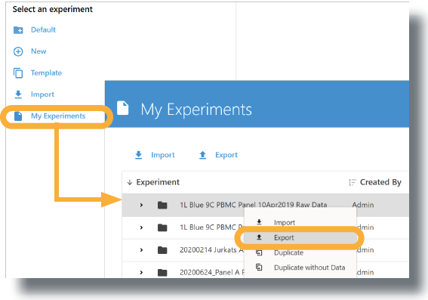
- Select a folder, type an export file name, and click Save.
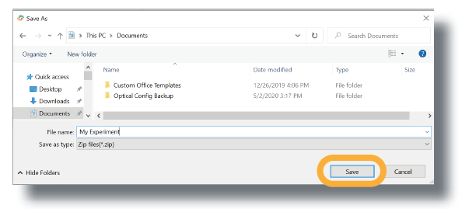

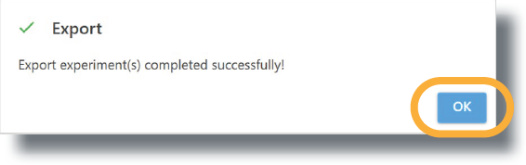
- Click OK to close the export pop-up window.
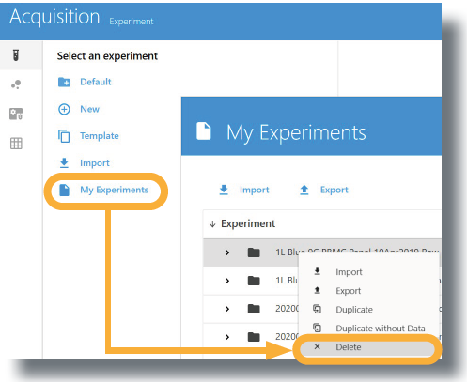
- Right click on the experiment in SpectroFlo Acquisition module > Experiment tab > My Experiments and click Delete.

- Click Delete to remove the experiment from SpectroFlo.
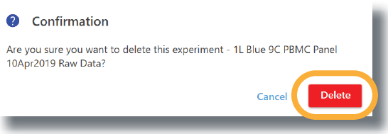
To open your saved experiment on another computer:
- In the acquisition tab, select Import.
- Locate your experiment on the computer (exported file is a zip folder).
- The experiment should automatically open and you can run your samples.
NOTE: Experiments will be saved in “My Experiments”.

FCS Files
FCS files generated from an experiment are stored in the Export folder by default, or the folder you set as the default. Experiments can contain the following types of FCS data files for each tube run:
- Raw data files only (for samples that were acquired in an experiment).
- Raw data files + unmixed data files (for samples that were acquired and unmixed live during acquisition).
- Unmixed data files only (for samples that were unmixed post acquisition).
Experiment Templates
Use the Save As option above the experiment’s tube/group (hierarchy) list to save the current experiment as a template, which can then be used for running similar experiments. Experiment templates include fluorescent tags used in the experiment, reference controls, groups/tubes, labels, worksheets, and stopping criteria. Templates are saved in the library. To open and use a template, select Template from the Acquisition Experiment menu.
