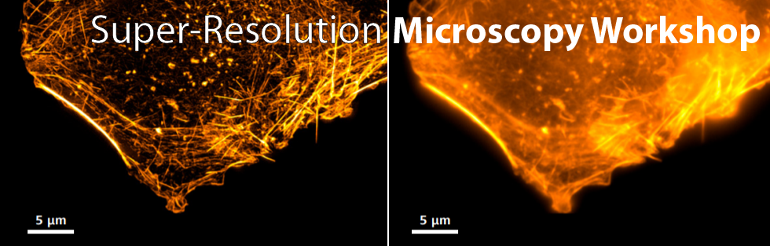

Course Application Form

Registration deadline
August 24, 2019

Selected participants will be notified by
August 28, 2019

General Information

Name*

Degree* Current Position*

Affiliation*

Address*

Postal Code*

City*

Country*

Email*

Phone

Lunches and coffee breaks are not included.

Microscopy Background

 | Low | Medium | High
Standard Fluorescence Microscopy *
Confocal Microscopy *
Super-resolution Microscopy *

What is your goal for attending the workshop? *

* mandatory field

